In previous blog we seen the prerequisites for connecting Android device to Appium. In this chapter we will find out the prerequisites for connect iOS real device/ Simulator with Appium

To automate iOS for mobile or iPAD OS for tablets, it is must to have a Mac machine.
XCode should be installed properly to get the SDK files for connectivity
XCode should be kept upto date to get the latest iOS/iPAD OS support
NODEjs must be installed in the device

What is WDA ?
WDA stands for WebDriverAgent. As the name says this is the bridge for Appium to send or receive Proxy commands.
WDA was developed by Facebook for their hybrid app testing. Later it was acquired by Appium and now it is managed by Appium team. Still you can see the WDA bundle ID comes with the name com.facebook.bundleID. WDA is designed using Objective C you can see the code by opening the WDA framework in XCode.

I always confuse with XCode and XPath just kidding…

It is a good practice to change the WDA bundleID from “com.facebook” to some generic name like “com.UIAutomation” or something. Else if you are using any client provided enterprise Apple DEV ID for compilation, then you can see facebook.com allover bundleID’s. Don’t worry changing BundleID cannot stop you from compiling or building the WDA code base.

How to Install WDA to iphone ?
- WDA comes with Appium desktop
- You can find WDA as a framework and not as an app.
- It is our responsibility to compile the WDA framework and installing it in the device for test
- Once installed make sure you have given access for the WDA from “Device and Management” option from General settings screen.

Where to find the WDA framework in Mac machine?

- Go to Finder and Applications,
- Search the Appium application and take right click
- Take “Show Package Contents” from right click menu
- Navigate to the path “Contents/Resources/app/node_modules/appium-webdriveragent/”
- Open the file “WebDriverAgent.xcodeproj” in Xcode.

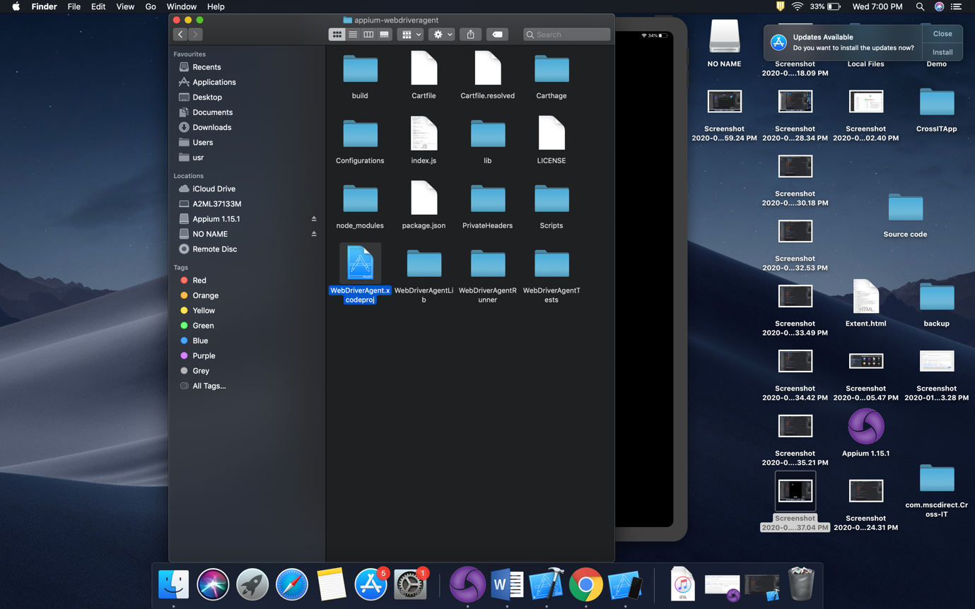

How to compile the WDA XCode file ?

Open WDA xcodeproj in XCode so that you can see the WDA program in XCode like below,

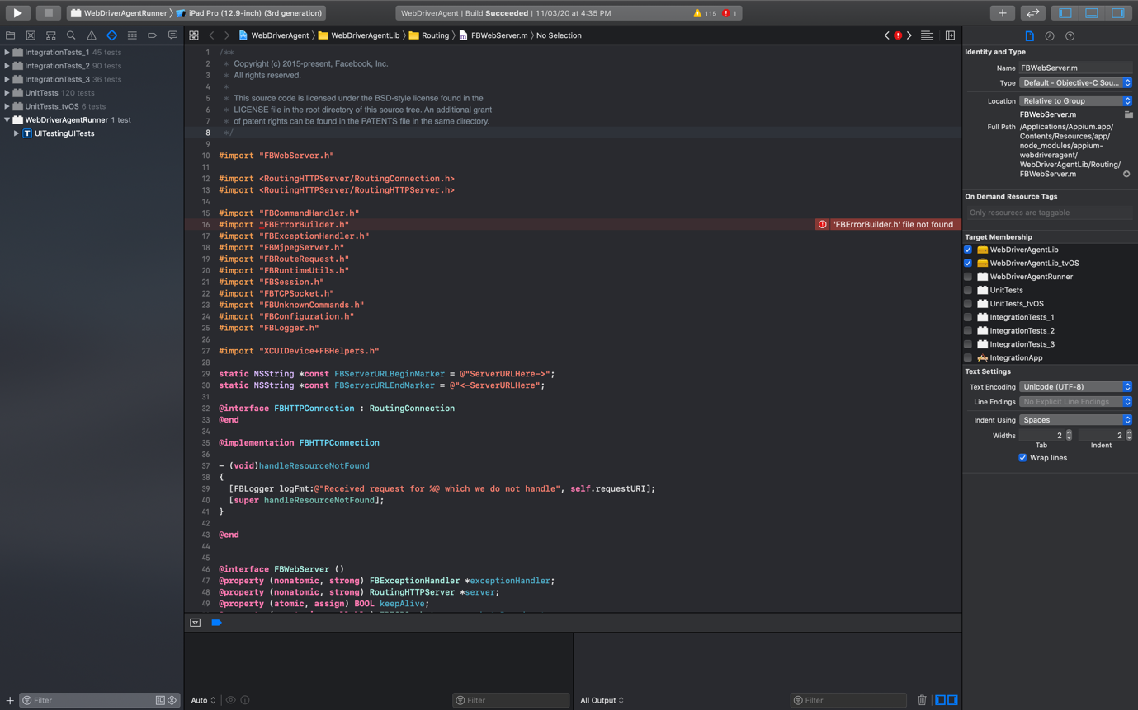

Make sure you have selected the proper device from the “Devices” list

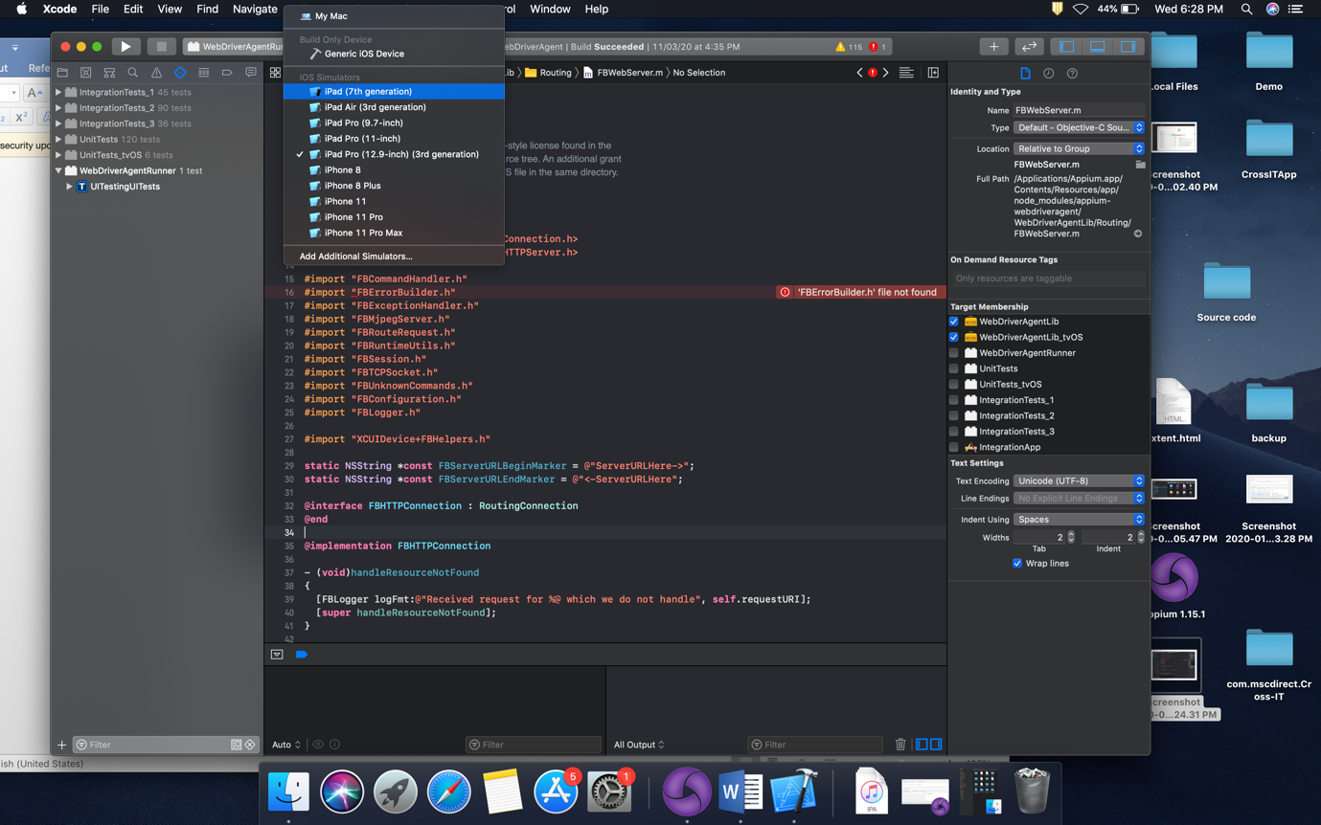

I have selected the option “iPad Pro (12.9 inch)(3rd Generation) simulator, it means I’m going to install WDA on simulator now

Now, go to “Product” click on “Build”

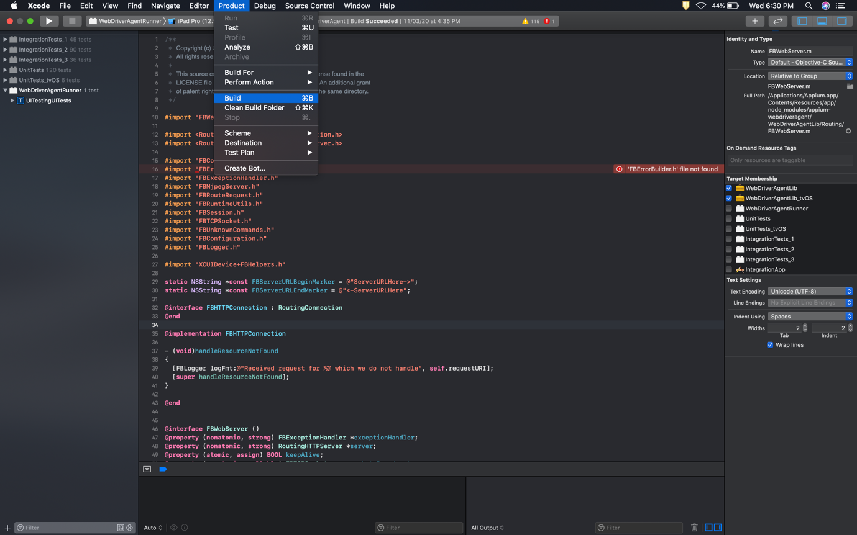

If you face any compilation issues you can find that in the left hand side menu like this

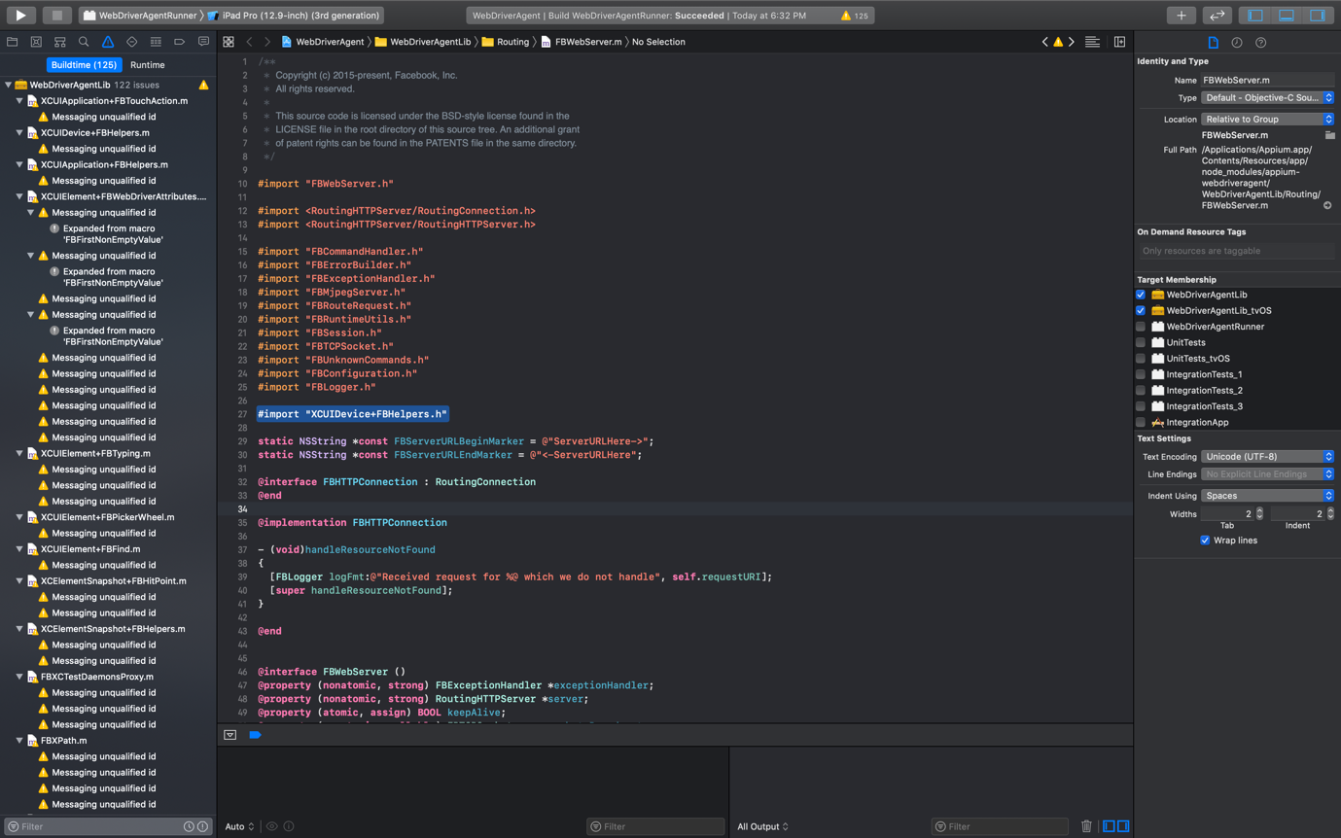

You can ignore the warnings and now Once Build is successfully compiled, go to “Product” and take option “Test”. This option will start the Simulator and install WDA

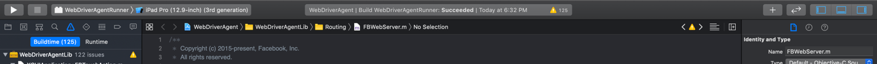

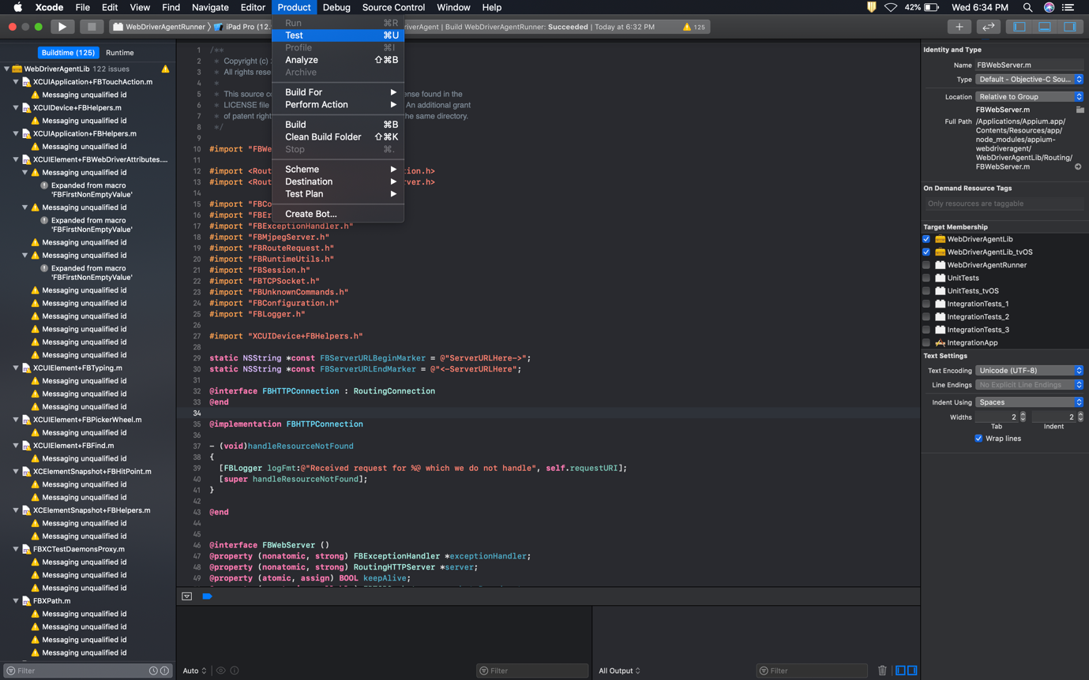

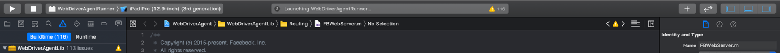

Now the selected simulator will be opened and the app will start installing on the simulator

WDA installed successfully on the Simulator

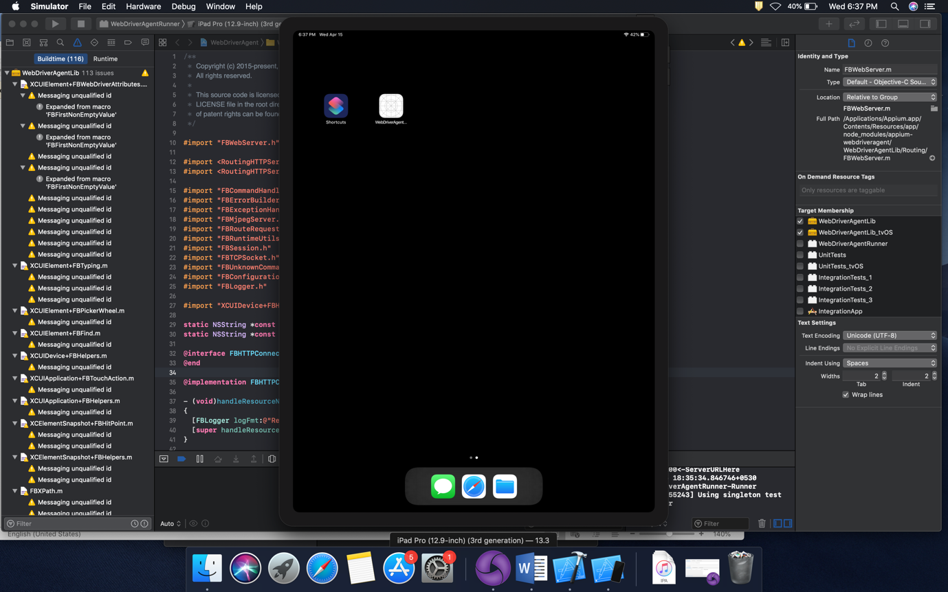

Do we have any limitation in using Appium on MAC Machine ?

As we all know Appium is a platform independent tool. We can run Appium on Windows/ Mac/ Linux. But yes there are few limitations when it comes to device platform.

- You can use Appium for Android using any Windows/ Mac machine.
- You cannot automate iOS application using Appium from Windows/Linux based machines.

Why Automating iOS is not possible with a Windows machine?

There are lot of reasons we can list out, few most common reasons are
- Windows by default will not have support for advanced iOS operations. You can perform only basic file data transfer option but installation of any app or debugging options are not available from Windows.
- XCode which is a commonly used SDK for iOS app. XCode support is not available for windows-based OS.
- Without XCode you cannot install WDA (WebDriver Agent) to iOS devices, so from windows it is impossible.

Commonly facing WDA installation/ compilation issues:

- Provisioning Profile:
  - If you are using your personal Apple development ID for more than 2 devices then you will definitely face provisioning profile issues while compiling. The solution is either you need to untag few devices from your apple dev account or you need to change the apple ID in your app build settings
- 'RoutingHTTPServer/RoutingConnection.h' file not found

For the first time if you are building WDA then you have to face this issue for sure. This is happening because of missing “bootstrap” script configuration. To overcome this issue, open Terminal and open the path where WDA project file exist, (“/Applications/Appium.app/Contents/Resources/app/node_modules/appium-webdriveragent/”) and type the command “./Scripts/bootstrap.sh -d”. This command will help you to resolve the h file not found issue.

- CocoaAsyncSocket.h not found
Again a common and must face issue while compiling WDA, This needs no action to be taken. Just close the XCode and open the WDA project again.
This issue may come if you have installed Appium CLI. Because the CarthageKit that installed as a part of Appium CLI may cause issue. If restarting XCode didn’t solve the issue then uninsall/remove CarthageKit from terminal using the below command
“rm -rf ~/Library/Caches/org.carthage.CarthageKit”

